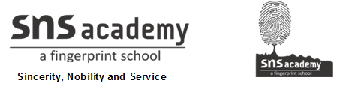

Marks obtained:

Total:
30
MONTHLY TEST FEBRUARY-2020
Name: ____________________________
Grade: I Section___
Subject: MATHS
Date: 21.02.2020
Time: 1 Hour

I. Choose the correct answers. 10x1=10
1. A design that gets repeated is called a ______________
a. rupee b. patterns c. money
2. We always subtract the smaller number from the____________ number.
a. lesser b. small c.bigger
3.________________ is used to buy things.
a. Money b. toys c.numbers
4. 21—5 = __________
a. 19 b. 20 c. 16
5.Money is used in the form of _______________
a. notes and coins b. food and water c.eyes and ears
6.75 -- 15 ____________
a. 50 b. 60 c.70
7. The pens are arranged as red, green,yellow, red, __________, yellow.
a. yellow b. red c. green
8.Complete the patterns
_______

a. b. c.
9. 30 – 1 = _________
a. 28 b. 27 c. 29
10. Indian currency symbol is _______
a. £ b. c.®
II. Fill in the blanks. 6x1/2=3
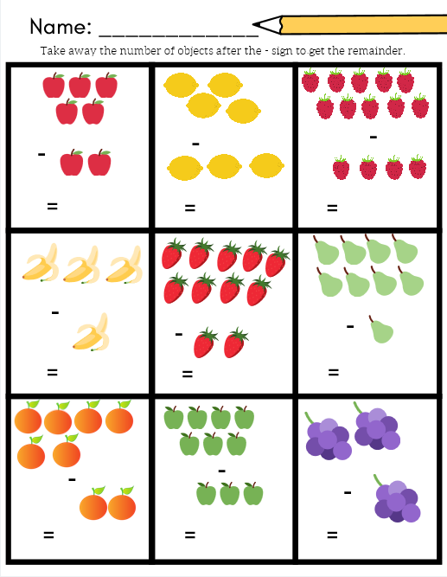

III. Draw the missing picture. 4x1=4
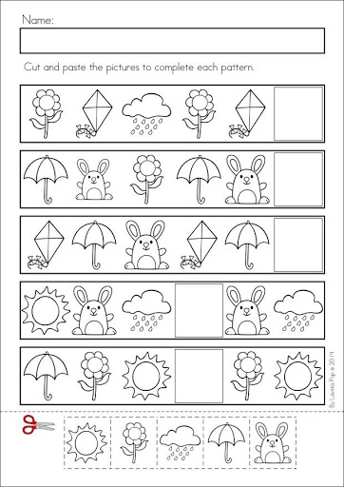

IV. Draw the patterns in the following. 2x 2 ½ =5
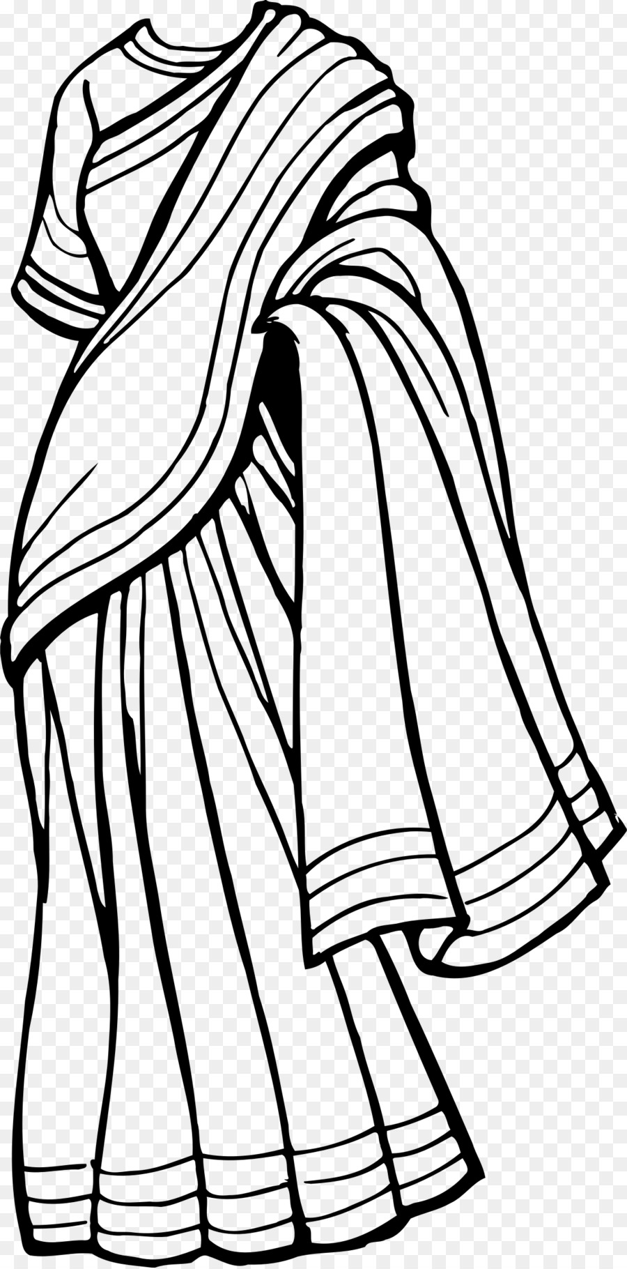
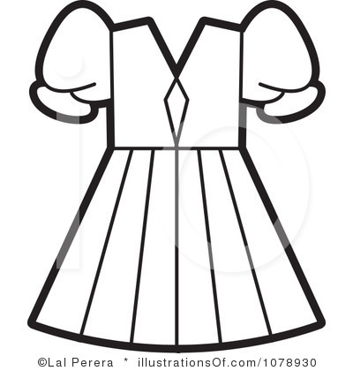

V. Complete the following. 4x1=4
11. Rs 10 + Rs 5 = _________________
12. Rs 20 + Rs 2 = _________________
13. Rs 100 + Rs 100 = _________________
14. Rs 2 + Rs 1 = _________________
VI. Draw the amount using notes and coins. 4x1=4
5
10
200
50

